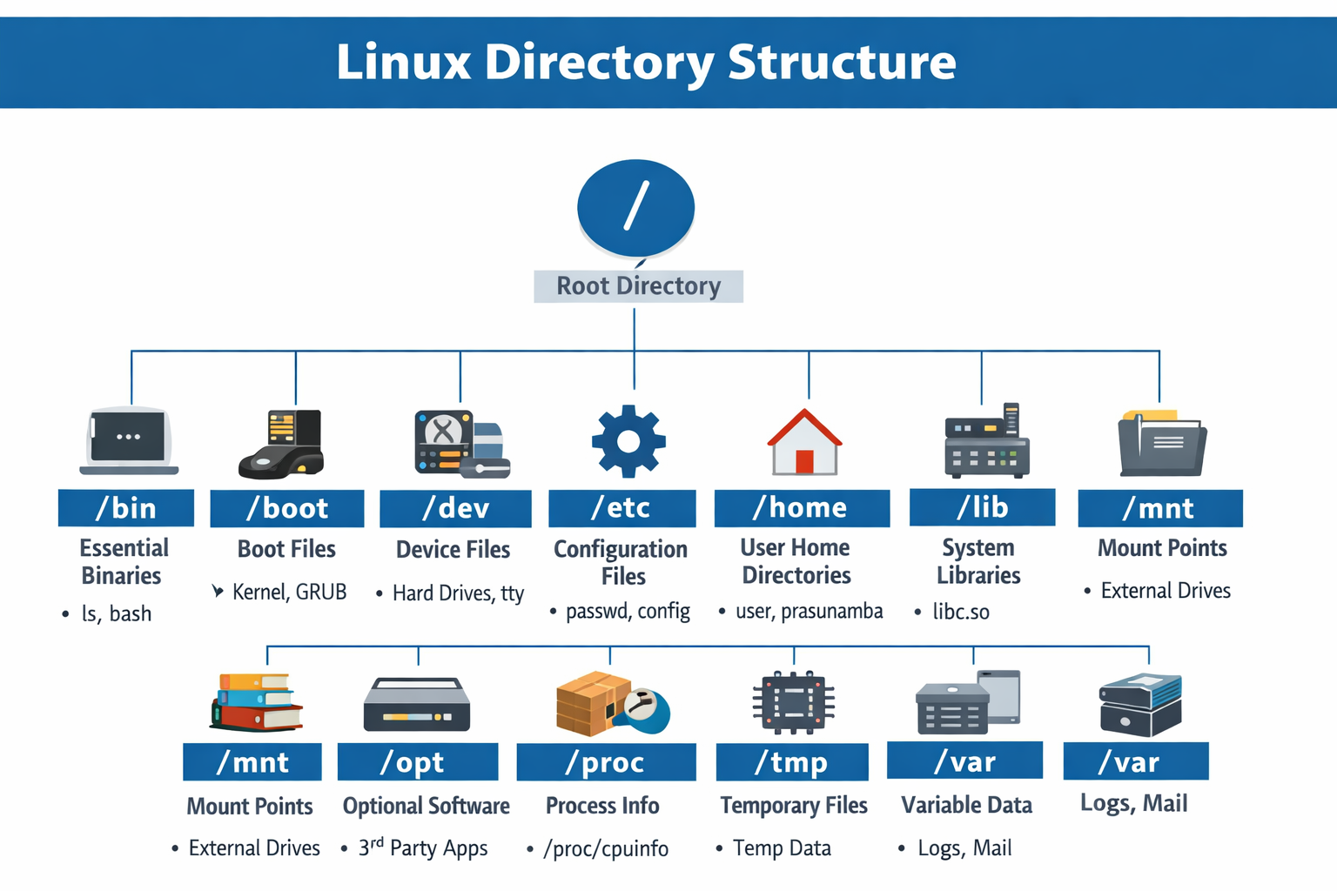

Directory | Purpose | Examples
/bin | Essential user commands and binaries | ls, cp, bash
/boot | Boot loader and kernel files | vmlinuz, grub.cfg
/dev | Device files (interfaces to hardware) | /dev/sda1, /dev/tty
/etc | System-wide configuration files | passwd, resolv.conf
/home | Personal directories for users | /home/prasunamba
/lib | Shared libraries for binaries | libc.so
/media | Mount points for removable media | USB drives, CDs
/mnt | Temporary mount points | External disks
/opt | Optional software packages | Third-party apps
/proc | Virtual files for kernel and process info | /proc/cpuinfo, /proc/meminfo
/root | Home directory for root user | /root/.bashrc
/sbin | System administration binaries | ifconfig, shutdown
/srv | Data for services (web, FTP) | /srv/www
/tmp | Temporary files (auto-cleaned) | Session data
/usr | User applications, docs, libraries | /usr/bin, /usr/share/doc
/var | Variable data (logs, cache, mail) | /var/log, /var/tmp

Linux quick reference cheat sheet

1. File System Navigation:
- pwd: Print the current working directory.
- ls: List files and directories in the current directory.
  - ls -l: Display detailed information about files and directories.
  - ls -a: Include hidden files and directories in the list.
- cd directory: Change the current directory to the specified directory.
  - cd ..: Go up one level in the directory hierarchy.
  - cd ~: Go to the home directory.
- mkdir directory: Create a new directory with the specified name.
- rm file: Remove a file.
  - rm -r directory: Remove a directory and its contents recursively.
- cp source destination: Copy a file or directory.
  - cp -r source destination: Copy a directory and its contents recursively.
- mv source destination: Move or rename a file or directory.

2. File Manipulation:
- cat file: Display the contents of a file.
- less file: View the contents of a file with pagination.
- head file: Display the first few lines of a file.
- tail file: Display the last few lines of a file.
- grep pattern file: Search for a pattern in a file.
  - grep -r pattern directory: Recursively search for a pattern in files within a directory.
9.59 to 10.10

3. File Permissions:
- chmod permissions file: Change the permissions of a file or directory.
  - chmod +x file: Add executable permission to a file.
  - chmod -w file: Remove write permission from a file.
- chown user:group file: Change the owner and group of a file or directory.
- chgrp group file: Change the group of a file or directory.
10.15 to 10.25

4. Process Management:
- ps: Display information about active processes.
  - ps -ef: Display detailed information about all processes.
- kill process_id: Terminate a process with the specified process ID.
  - killall process_name: Terminate all processes with the specified name.
- top: Display real-time information about system processes.
- bg: Put a process in the background.
- fg: Bring a background process to the foreground.

5. System Information:
- uname: Print system information.
  - uname -a: Print detailed system information.
- whoami: Display the current user.
- df: Show disk space usage.
- free: Display memory usage.
- uptime: Show system uptime.
- ifconfig: Display network interface information.
- ping host: Send ICMP echo requests to a host for network connectivity testing.

6. Text Editing:
- nano file: Open a file for editing with the Nano editor.
- vi file: Open a file for editing with the Vi editor.
- grep pattern file: Search for a pattern in a file.
  - grep -r pattern directory: Recursively search for a pattern in files within a directory.
- sed 's/old/new/g' file: Replace occurrences of a pattern with a new value in a file

7. Compression and Archiving:
- tar cf archive.tar files: Create a tar archive of specified files.
- tar xf archive.tar: Extract files from a tar archive.
- gzip file: Compress a file using gzip compression.
  - gzip -d file.gz: Decompress a file compressed with gzip.

8. Networking:
- ssh user@host: Connect to a remote host using SSH.
- scp source destination: Securely copy files between local and remote hosts.
- wget url: Download a file from a specified URL.
- curl url: Transfer data to or from a server using various protocols.

9. User Management:
- useradd username: Create a new user account.
- userdel username: Delete a user account.
- passwd username: Set or change the password for a user account.
- su username: Switch to another user account.
- sudo command: Execute a command with superuser (root) privileges.

10. Package Management:
- apt-get install package: Install a package using the Advanced Package Tool (APT) package manager.
- apt-get update: Update the local package index to retrieve the latest package information.
- apt-get upgrade: Upgrade all installed packages to their latest versions.
- apt-get remove package: Uninstall a package.
- apt-cache search keyword: Search for packages based on a keyword.

11. File Transfer:
- scp source destination: Securely copy files between local and remote hosts using the SSH protocol.
- rsync source destination: Synchronize files and directories between local and remote hosts efficiently.
- sftp user@host: Start an interactive secure file transfer session with a remote host.

12. System Monitoring and Maintenance:
- top: Monitor system processes and resource usage in real-time.
- htop: Interactive process viewer and system monitor.
- du -sh directory: Display the total size of a directory.
- df -h: Show disk space usage of mounted file systems.
- reboot: Reboot the system.
- shutdown: Shutdown the system.

13. Networking and Connectivity:
- ifconfig: Configure and display network interface information.
- ping host: Send ICMP echo requests to a host for network connectivity testing.
- netstat: Display network connection information, routing tables, and interface statistics.
- ssh user@host: Connect to a remote host using SSH.
- nc host port: Open a TCP or UDP connection to a remote host on a specified port.

14. System Information:
- uname -a: Display detailed system information including the kernel version.
- lsb_release -a: Show distribution-specific information about the Linux distribution.
- hostname: Print or set the system's hostname.
- date: Display the current date and time.

15. File Permissions and Ownership:
- chmod permissions file: Change the permissions of a file or directory.
- chown user:group file: Change the owner and group of a file or directory.
- chgrp group file: Change the group of a file or directory.
- ls -l: List files and directories with detailed permission and ownership information.

Task 1:

What is the default permission for a newly created file and a directory?

11.05 to 11.08

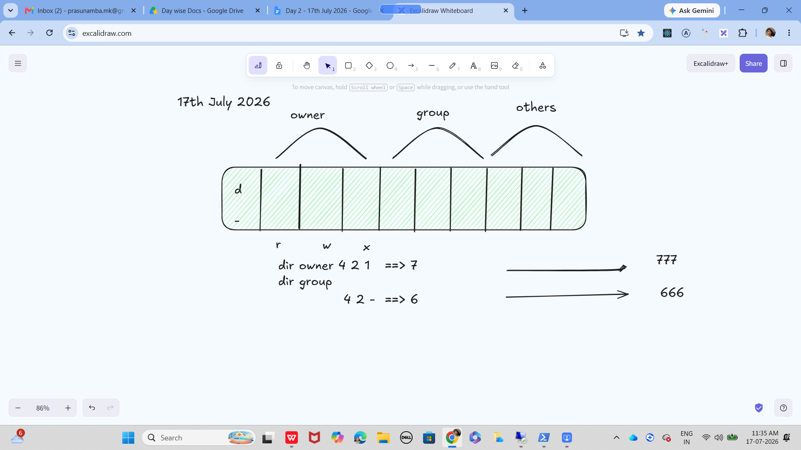

Task 2:

Create a user using linux
11.45 to 11.48

Useradd Prasunamba
Or
Sudo adduser Prasunamba

Task 3:
Delete the above user

Task 4:
Create another user
Change the password
Create a third user and switch to 2nd user

Task 5:
Find your system’s current time.

Task 6:
What is the chown command used for?

Task 7:

What is grep used for ?

Task 8:
How to use Redirecting in linux?

Task 9:
Try to open any file using vi command..

To insert text use i - insert
Esc :wq – to exit

Task 10:
Try to use hostname command

Task 11:
Try to use uname -a to display detailed system information including the kernel version.
Task 12:
Try to use Sudo command (write any command here )

Task 13:
What do you understand by HTTP and HTTPs?
2.11 to 2.13

Task 14:
What are methods in HTTP protocols
2.14 to 2.16

Task 15:
Give few status codes in Http protocols
2.17 to 2.20
Task 16:
What do you understand by Headers in Http..
2.21 to 2.23

Task 17:
Ppt show case of

Load Balancers - Team 1 and Team 3
Client Server communication patterns - Team 2 and Team 4

2.42 to 2.52 to 2.57 to 3.00

Home :
Task 1:
Awk

Task 2:
Sed

Task 3:

Piping

Data structures 👍
https://drive.google.com/drive/folders/1iQhB9_bVyf10ZlGOARjFNO1D4rJsmOEy?usp=sharing

